Twitter Marketing Made Easy

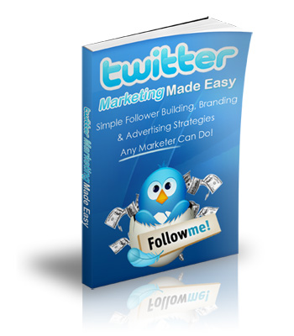

Simple Strategies For Building More Followers, Branding Your Business & Advertising On Twitter!

This ebook is Distributed and Copyright © by Your Name and www.YourWebsite.com

Ebook Rights:

Note: Please explain the rights that want to give with this ebook here.

Example: You have Personal Rights Use Only to this ebook. You may NOT give it away for free under any circumstances.

You may not sell it unless you have purchased or acquired Resell Rights or Master Resell Rights through the original publisher/distributor (www.StuartStirling.com ) or from an official reseller.

LEGAL NOTICE:

The Publisher has strived to be as accurate and complete as possible in the creation of this report, notwithstanding the fact that he does not warrant or represent at any time that the contents within are accurate due to the rapidly changing nature of the Internet.

While all attempts have been made to verify information provided in this publication, the Publisher assumes no responsibility for errors, omissions, or contrary interpretation of the subject matter herein. Any perceived slights of specific persons, peoples, or organizations are unintentional.

In practical advice books, like anything else in life, there are no guarantees of income made. Readers are cautioned to reply on their own judgment about their individual circumstances to act accordingly.

This book is not intended for use as a source of legal, business, accounting or financial advice. All readers are advised to seek services of competent professionals in legal, business, accounting, and finance field.

You are encouraged to print this book for easy reading.

Copyright Notice:

All content published within this ebook is protected by copyright and may not be reproduced without permission or altered in any way shape or form.

MATERIAL CONNECTION DISCLOSURE

You should assume that the author and publisher have an affiliate relationship and/or another material connection to the providers of goods and services mentioned in this report and may be compensated when you purchase from a provider. You should always perform due diligence before buying goods or services from anyone via the Internet or offline.

TABLE OF CONTENTS

- Introduction
- Chapter 1 - Building A List Of Twitter Followers
- Chapter 2 – Tools To Make Twittering Easier & Better
- Chapter 3 – Turning Twitter Followers Into Customers
- Chapter 4 – Maximizing Your Twitter Traffic
- Chapter 5 – Common Mistakes Twitter Users Make
- Chapter 6 – More Twitter Marketing Insights

Introduction

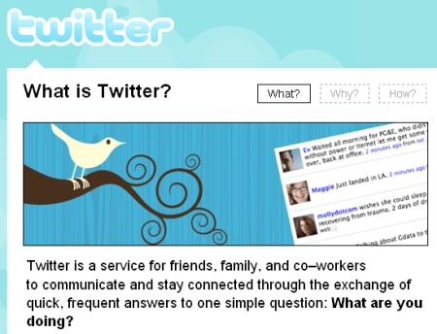

About Twitter

In this ebook, you’ll learn all the ins and outs of using Twitter and using it as an essential marketing resource for your Internet business. If you haven’t heard the buzz about Twitter yet or are still wondering what the real purpose of twitter is all about, let me try to explain.

Twitter in a nutshell is a simple social networking website that lets you share with your friends know what you’re doing – right now! Hence the old catch phrase on the Twitter sign-up page –“What are you doing?” Think of Facebook, instant messaging and sms all rolled into one simple package, and you’ve got Twitter.

Twitter works around a time line which is displayed on a single page that’s updated every second of every minute of every hour….you get my point. It’s a constantly updated stream of news from people all around the world. As a member, you can add your own little message to the time line up to 140 characters long to it known as a "tweet".

But that doesn’t mean you’re going to be able to see every Twitter user’s Tweets. You can choose who you want to “Follow” and others can choose to Follow you. And it’s these followers who you can converse (tweet) with.

You might be thinking “wow, big deal” but there is massive potential in this mini social networking site to meet other like-minded people, share info and web site links. And those factors mixed with the ability to grow your followers make it a perfect platform for business.

You can also use Twitter to….

* Send direct messages to users instead of broadcasting to everyone,
* Mobile options to send and receive tweets via SMS and email from your cellphone,
* Search options allowing you to find Twitter users posting about a certain topic,
* An API that allows 3rd party developers to develop some great applications.

It’s taking the world by storm and there is a great potential for business owners, online and off, so if you’re not a member yet, sign up for a free Twitter account now.

Chapter 1 – Building a List Of Followers On Twitter

In this first chapter let's talk a little about how you can start building a large network of friends, clients, associates, and customers using the social networking website Twitter.

Many new users of Twitter are constantly asking how they can use the site more effectively for their business and since the site has grown into an Internet mega monster that is globally known and talked about, they are right to ask. The fact is Twitter is a fantastic tool for your IM business.

Internet relationships are very different from actual personal relationships. They are based primarily on like, know, and trust. Many people are reaching out to others through social network websites like Twitter, Facebook and many others.

If you are new to Twitter you may not realize that you can create your personal or business brand and virtually dominate your market, simply by building a list of followers.

Setting Up Your Profile

Once you've set up your Twitter account you will want to work on setting up your profile. Twitter lets you easily customize the look and feel of your profile page. You will want to pay close attention to your one line bio.

Bio Line
Because, besides your Tweets, this is what people will read and judge what type of person you are before they decide whether or not they want to follow you. You will only have 160 characters to describe who you are and what you do, so you have to make it good!

Photo
It’s essential that you use a real photo of you over an image your company logo. I recommend you use a real photo because people connect with real people and trust a user with a face. A user profile that has a business logo just screams sales and is a turn off for most people.

Background
You also have the option to upload a customized Twitter background to your profile. This is something you will want to utilize ASAP as this is a massive benefit and way to get free exposure for you or your company.

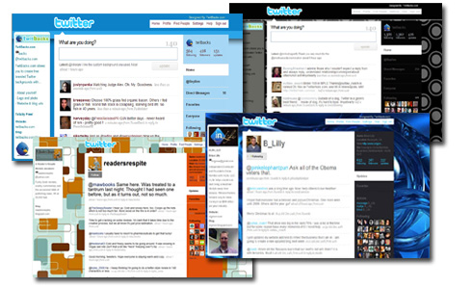
There are a ton of free Twitter backgrounds that you can download edit with photoshop floating around or you might want to get one made up professionally by a designer.

Get Followers

The next thing you will want to do after your profile is set up right is start to get ‘followers’. If you have business contacts or an email list that are already using Twitter, invite them to follow you.

Put your twitter url in your emails, on your websites and blogs asking people to follow you. You could even put your Twitter url on your business card, so that you can gather followers from offline as well.

Don't be shy; tell everyone you meet about your Twitter page. Make is sound exciting and let them know that you will be sharing important updates, great tips and information with them if they follow you. You may be surprise to find out that almost everyone will click the follow button just to see what you're up too!

Another thing that I feel that is important especially for Internet marketers is to seek out and follow the ‘gurus’ and the powerful users of Twitter. This will benefit you in more than one way. It will give you a bird’s eye view of what they’re doing on Twitter, so you can learn how to improve your own results and it will also put you in front of all the people they are in contact with.

Curiosity, you can't fight it, so you may as well take advantage of it. People are curious by nature! They like to see who is following who, so often they will click on the links and check out the followers of people they know and follow them as well and by following the leaders, so to speak you may naturally end up will new followers as well. Just try and keep your target market in mind when you choose ‘gurus’ to follow.

Re-Tweeting

Now let's talk about getting your Tweets spread even further and increasing the chance of meeting even more people by using 're-tweets’.

Re-tweeting is a common practice on Twitter where you’ll re-post someone else’s tweet that you like and you think your followers will like.

With this method, you take the original twitter message someone else has posted, and rebroadcast that same message to your followers. To do a re-tweet, simply type in RT at the beginning of your tweet and then a @ before the original tweeters username followed by their original tweet.

Now Twitter will let you click the Retweet button on the Twitter website which will set up the RT function automatically.
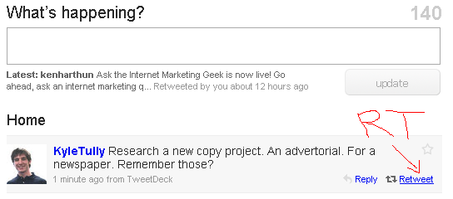

Reasons To Re-Tweet

When broadcasting the message, you should definitely give credit to the original poster in the way I showed you above. I know at first it may sound like this will only be good for the original tweeter, but retweeting can actually benefit you just as much if not more because;

1. It provides more value to your followers.

When you provide value to your followers, you make them happy! You are also more likely to attract followers. Providing quality content is always a great way to build your business no matter what platform you use.

2. It will benefit your brand.

If you point a reader to a source if good information that is truly relevant and beneficial to them, the amount of trust that they have in you will increase.

3. It will help you build relationships with the original posters.

Retweeting someone else’s content is an act of kindness, and for the most part bloggers like to return the favor. You shouldn't expect someone to re-tweet your content just because you retweet theirs. Just keep in mind that your chance of being on the other end of a re-tweet increases as you retweet.

Retweeting is all about providing value to your followers so if you want others to retweet your post then you want to make sure that you are providing them with quality content worth tweeting about.

The bottom line is retweeting is a great way to add quality and value to your Twitter page. If done right, retweeting can help you educate your followers, build your personal brand, increase future traffic, and connect you to other great people in your niche.

Just be careful if you use it incorrectly, retweeting can actually hurt your personal brand and future traffic. You want to treat your followers like gold. Don't ever send them to inappropriate websites or spam them with one sales pitch after another.
Chapter 2 – Tools To Make Twittering Easier & Better

In this lesson we are going to go over some tools that you can use to make your life as a marketer on Twitter easier and in turn better for your overall success.

Tweet Deck

I don’t know about you, but I find the standard Twitter.com interface quite inefficient and sometimes very slow moving. That’s why I prefer to use Twitter through a free tool called TweetDeck. TweetDeck is a free downloadable application that works from your desktop and connects to your twitter account.

The main benefits of Tweetdeck is that you can see the main Twitter time line, the mentions you get and your DM’s all on the one screen.
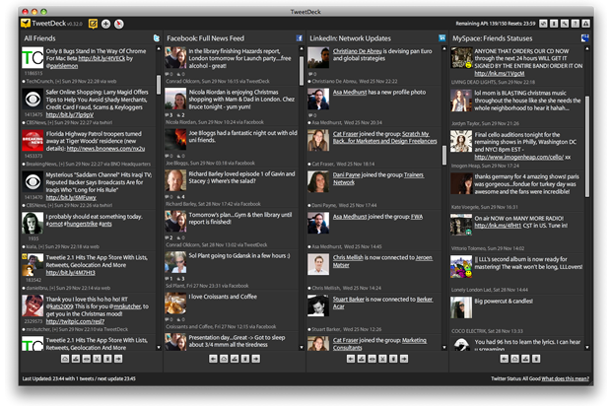

This interface design makes it much easier to manage your Twittering. The other good things about it are you can control multiple Twitter accounts from it, re-tweet with one click and follow/unfollow – all from the one place. You can also see your Facebook timeline too!

Get TweetDeck free here.

Social Oomph

Our next tool is Social Oomph – formerly known as Tweet Later. This tool lets you schedule your tweets, auto-follow people who follow you and send them a DM (direct message) automatically and much more.

Social Oomph offers a free service but there is also the option to upgrade for even more features. Let’s look at the main benefits of using a tool like Social Oomph:

- You can schedule tweets to go out automatically at a time you set. This is great if you aren’t able to send important tweets because you have other commitments. It only takes a few minutes to set up and you can use to automatically post your prepared tweets.

This can be handy for business if you are preparing a product launch or an even such as a teleseminar/webinar and want to keep your followers up to date about it but don’t want to be manually posting to Twitter.

- You can select the option to auto-follow people who follow you and send them a DM at that time automatically. This is a great way to introduce yourself and make friends quickly. You can add a short message in the DM that goes “thanks for following me. I’m an expert in ABC so please let me know how I can help you.”

Just make sure your message doesn’t go over 140 characters. You probably don’t want to send them straight to your website or else they’ll smell you as just another ‘salesy’ person right away.

You can find out more about Social Oomph here.

TwitPic

Sharing pictures and product images is also possible with Twitter by using the tool Twitpic. When you make new contacts there may come a time when you want to share some of your pictures with them so that they can get to know you and your business better.

Once you’ve created your Twitpic account you can upload your pictures and quickly post them on Twitter. Another great thing about this tool is that it is also compatible with mobile devices which make it easier to share pictures from your mobile device. You can find out more about Twitpic here: http://twitpic.com

Wordpress Plugins

If you are using Wordpress for your blog, there are quite a few tools that you can use to automate your Twitter activities from inside your dashboard including:

TweetThis plug-in - It will encourage your visitors to tweet your blog post. TweetThis also adds a Twitter link in every blog post you create plus gives you the ability to shorten your blog post URL to fit the 140-character limit.

TweetMeme button - Helps other people to easily retweet your post on Twitter and it also shows a count of how many times your blog post has been retweeted. It’s the cool green button you see in the screenshot below.
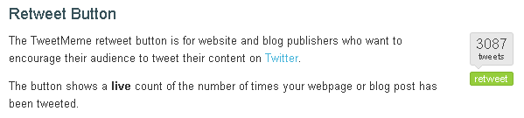

Twitter Tools - This plug-in integrates your blog with Twitter by pulling all your tweets into the side bar of your blog. You can also use it to post new tweets from inside your WordPress blog.

Twollo

Now let's talk about Twollo. It is another web based Twitter tool that you can use to find specific people you want to follow. Just type in the subject or topic that interests you and the tool will find people who are talking about the same thing and automatically follows them for you.

And the list goes on. I could literally list hundreds of tools that work with Twitter for you, but then we would be stuck on this lesson for days. So these tools will help you for now.
Chapter 3 – Turning Twitter Followers Into Customers

In this chapter, we’re going to talk about how you can gather new customers with Twitter. I have some great tips for you that will help you increase your chances of converting your regular twitter followers in to lifelong customers.

Research Your Market

Let's jump right in and talk about how you can use Twitter to conduct your market research. Every business has a target market, but the simple fact is that many business owners often miss the mark because they don’t know the true needs of their market.

By using Twitter, you can easily listen to the needs of your prospects, the issues they are currently facing and the kind of help that they want.

Whenever you meet someone new on Twitter it's a good idea to try to establish a good relationship from the start. Think like your customer. You buy from people who you trust and like. Your target market also behaves the same way. It is important, especially in social marketing that you get to know your clients and do your best to win their trust and confidence.

A good rule of thumb is to try and keep 90% of your tweets full of helpful content and try to limit your promotional ones. By doing so, you can attract more followers and hopefully customers.

Share Your Expertise

In order to show off your expertise on Twitter you will want to post quality content on your blogs, website and other sites, like article directory EzineArticles.com. Then share them with your followers.

As we talked about in the last chapter, there are a wide variety of tools that work with Twitter that will automatically check the blogs you’ve posted and share them instantly on your page. Offering educational materials, seminars, video training and networking events will also go a long way when you are trying to convert your followers into paying customers.

If you're not camera shy, plug in your webcam and use this great service that allows you to stream live video on your Twitter page and chat real time with your followers! This will be a fantastic way to make an instant connection for you and your peeps.

You can find out more here:
http://twitcam.com

There are so many different techniques that you can use to help the transition from follower to customer by using Twitter. Just remember to keep the value of your content high and the volume of your promotions low and you will begin to see more of your followers clicking on your promo links and turning into customers.

Chapter 4 – Maximizing Your Twitter Traffic

As an Internet marketer one of your main promotional goals should be to dominate social networks and what better way to access the global market than through Twitter. Simply by attracting followers and making friends you can quickly build a list of valuable leads.

Did you know that Twitter is considered to be one of the most effective and impressive ways to increase traffic?

Most people use Twitter simply to send tweets to one another and keep in contact with friends and family, but as an Internet marketer you can use it to drive traffic a serious amount of to your business sites if you know how.

Just imagine, with the increased traffic to your website, you can gain more subscribers, leads and convert them into paying customers which all leads to increased income.

Let The World Know You’re On Twitter

As we talked about in chapter one, you need to spread the news that you’re on Twitter. You will want to include your Twitter url in your email messages, post blogs and on your websites. That way, everyone will know that you’re using Twitter.

Tweet Good Content Often – Daily Not Weekly!

Believe it or not regularly updating your tweets will help you drive more traffic to your site. Avid Twitter users like people who post tweets regularly. If you want to gain active followers through your tweets you will want to set up a schedule for posting and do your best to stick to it.

You will also want to make sure that you reply to the tweets addressed to you. I don't recommend that you stay on the site all day or spend long hours tweeting away your time. Just pick a good time once or twice a day and login.

If you have a mobile device, all the better because you can sync it up with your Twitter account and you won't have to worry about being away from your computer.

Don't worry if your followers don't become active right away. It may take some time, but they will begin to notice the times that you are more active and after a while they will join in your conversations, which is one of your main goals.

Just remember the basic rule we talked about in chapter three "keep 90% of your tweets full of helpful content and limit your promotional ones". This way you will keep the followers that really matter.

While some personal tweets are a must if you want to help your followers get to know you, you will want to avoid sending out to many personal or unrelated tweets because it can actually cause you to lose followers. After all there aren't too many of your business contacts that will want to hear that you took a shower or what you had for breakfast, so keep your tweets focused!

By taking the time to build good relationships with your followers, you will be laying the ground work for converting them into lifetime customer for your products or business. Establishing a good relationship with your followers is vital if you want to take advantage of the massive flow of traffic that pours through Twitter every day.

Here is a little checklist that you can keep handy:

- Let everyone know that you’re on Twitter.
- Send tweets regularly.
- Retweet good content.
- Reply to the tweets addressed to you.
- Pay attention to the kind of tweets you’re sending.
- Make the tweets personal, but not too personal.
- Most of all, build good relationships.

Using Twitter is fun and easy that is why is has such a big draw. I'll be honest, not everyone who uses Twitter as a marketing tool will be successful because it takes time, effort, and patience to see effective results. But if you follow these steps regularly you should see an increase of activity and conversion.

Chapter 5 - Common Mistakes That Twitter Users Make

Over the last few days we've talked about what an exciting, cool, and extremely profitable social network site Twitter is. The fact is millions of people are using it to connect with each other all over the world, but as an Internet marketer there are some common mistakes that you will want to avoid making even before you start sending tweets.

Mistake number one: Not using your picture as your profile avatar!

I'm sure you've seen it. Some users don’t post their real picture. Admittedly, a cartoon picture, or a cheaply made company logos is better than no picture at all. But the bet picture you can use if you want to make a good impression and get people to remember you is a photo of your face.

When you post your own picture it lets others know that you are real and that you’re confident enough with what you do to let others see you. You want people to recognize you as a leader in your market and having a face to go with a name always helps. A nice smile never hurts either.

Mistake number two: Automatically sending the wrong type of direct message through an AutoDM.

In chapter two we talk about using the tool Future Tweets that automatically sends messages to people who follow you. What we didn't talk about was sending the wrong type of message with this tool and how it can lose you followers.

Direct messages can be seen as impersonal and pushy when they aren't written properly. If you decide to use a tool that automatically send messages to your new followers keep it simple and friendly. A message saying ‘thanks for following me’ is fine, but sending automated messages promoting your business or product is not a good idea and most instances people will click the unfollow button right away.

Mistake number three: Trying to build a huge following before you have done some tweeting.

People will not be interested in following you when they click on your Twitter page to see what you've got, and notice you don't have much. You need to have tweeted more than, "Trying to figure this Twitter out" and "I think I've got it figured out now."

If you don't know what to say, try "retweeting" (RT) some other peoples' tweets that that are related to your niche. Read what other people are tweeting about and reply to them, this will help start up a conversation. Talk about market related news, what you're doing on your business right now. That will give you several tweets to get the ball rolling.

Mistake number four: Tweeting promotion after promotion.
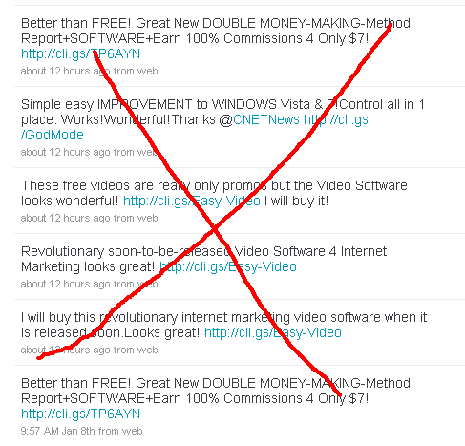
Yes, you are using Twitter to promote your business, but posting one offer after another will only cause people to ‘unfollow’ you. When people look at your timeline and notice that you aren't posting anything of value to them they will quickly move on.

There are millions of Twitters to follow, why should they follow you when you're only tweeting about promotions? Remember this basic rule of sales "people want to know what's in it for me"?

Twitter is a social network filled with real people and you have to keep that in mind before you post a tweet. When you are using Twitter for your IM business you must learn how to communicate and build good relationships with your followers before you start sending them with promotions.

Even if you already have a good list of leads, it is still not a good idea to barrage them with promotions. As we have talked about before, promotional tweets should be sent only in limited numbers.

These are just a few of the more common mistakes committed by new and old tweeters alike. Take note of them and don’t make the same mistakes.

Chapter 6 - More Twitter Marketing Insights

In this final chapter, I want to share a couple of more things with you that we didn't have a chance to go over in depth in the last few chapters.

Twitter Search

The first thing is using the Twitter search feature. It is a very effective tool that allows you to check on yourself and your business. You will be surprised to find out how much chatter takes place on Twitter.

By using the search tool you can quickly find out what others are saying about you and your business and learn from them. If you find out any criticisms, think about them carefully. You can also make some adjustments to your business if there is a need to so that you ensure profitability.

Twitter Backgrounds

A custom Twitter background is very important if you’re a beginner who hasn’t got your name established yet. When people see your tweets and are wondering whether to follow you or not, they will go to your profile page to see more about you.

When they see your custom background, they can tell you are serious about your business and about helping your followers on Twitter. It just adds that extra bit of professionalism to your image. The background on Twitter page tells a lot about your personality and the quality of your business.

If you want to save time and get a hot looking background created, the best way to go is to hire a designer to create one for you. If you want to do it yourself, there are many pre-made Twitter backgrounds available you can edit using photoshop or gimp etc.

Your custom background design can vary depending on your business, but always have your face with a smile, your name and your company name, website url and logo (if you have one).

Conclusion

Capitalizing on Twitter’s growing popularity can be very rewarding and profitable for your Internet business if you go about it with some tact and guile.

Twitter is growing at an alarming rate so expect Twitter functions and features to change and improve in the future. Developers are also busy creating new tools and applications to make the most out of Twitter so keep an eye out for many new tools making their way into the twitter marketing scene.

The main thing though is to use Twitter with good business sense and not abuse the power that it offers. Keep learning and using it and as long as Twitter exists, I'm sure great things will come.

Best of luck using Twitter to market your internet business!
Your Name
www.YourWebsite.com
Follow Me! Your Twitter URL

Check Out These Other Resources To Help You With Twitter!
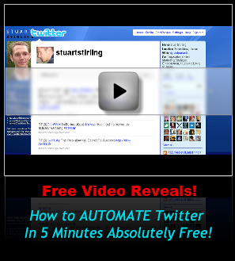
- Free Video Reveals: How To Fully Automate Your
Twitter With Great Content In 5 Minutes For Free!
Click Here To Get Free Access To The Short Video

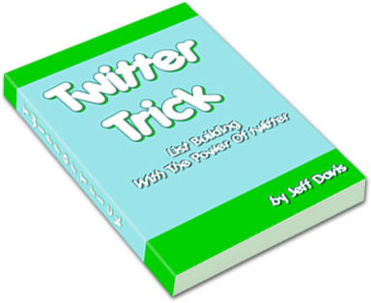
- Twitter Trick Ebook – How To Sky-Rocket
Your Twitter Followers!

Click Here To Download The Twitter Trick Report For $5

